**SERVICES & DAEMONS**

**What are Services and Demons?**

* Services and Daemons are similar types of programs that run in the background to perform tasks without user intervention.

**START SERVICES**

**SYNTAX:**

* systemctl start firewalld.service

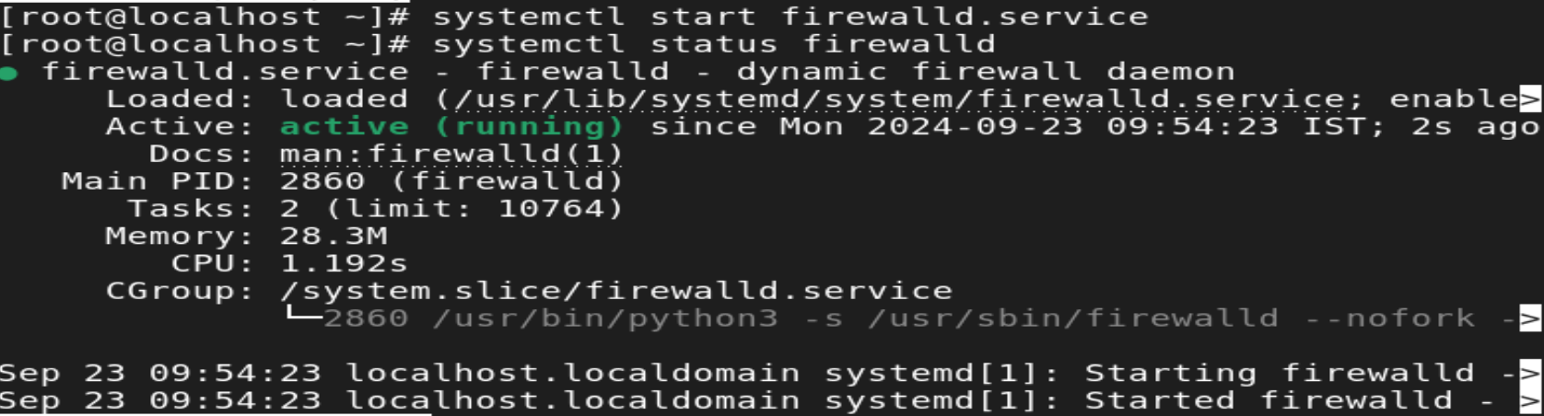

**STOP SERVICES**

**SYNTAX:**

* systemctl stop firewalld.service

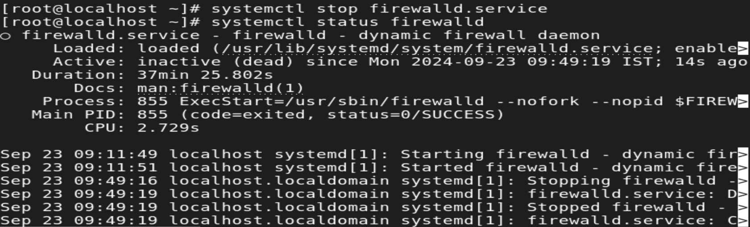

**STATUS SERVICES**

**SYNTAX:**

* systemctl status firewalld.service

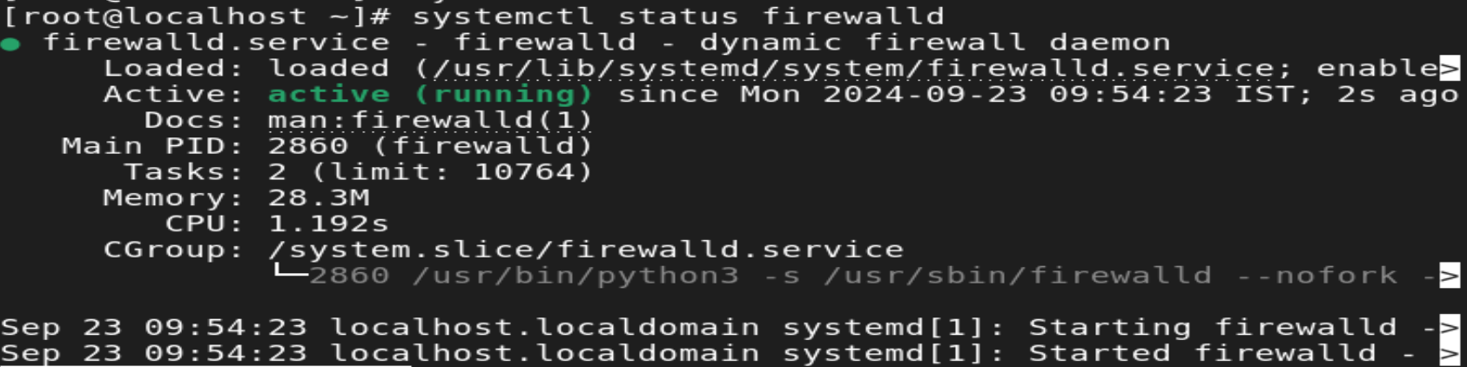

**RESTART SERVICES**

**SYNTAX:**

* systemctl restart firewalld

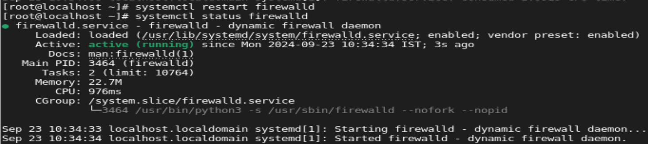

**RELOAD SERVICES**

**SYNTAX:**

* systemctl reload firewalld

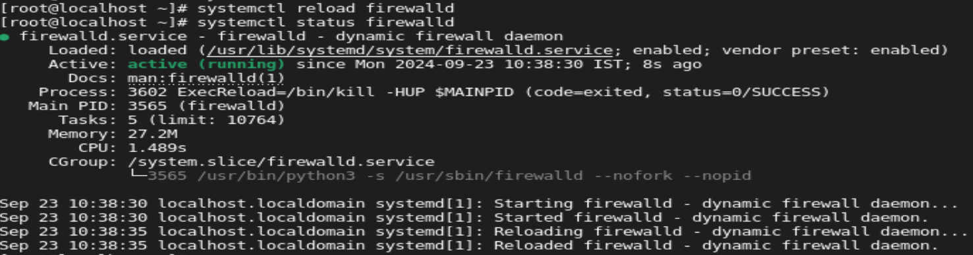

**IF SERVICE IS INACTIVE IN RELOAD COMMAND:**

* if service is inactive, cannot be reload.
* Only the service is active, it can be reloaded.



**ENABLE SERVICES**

**SYNTAX:**

* systemctl enable firewalld

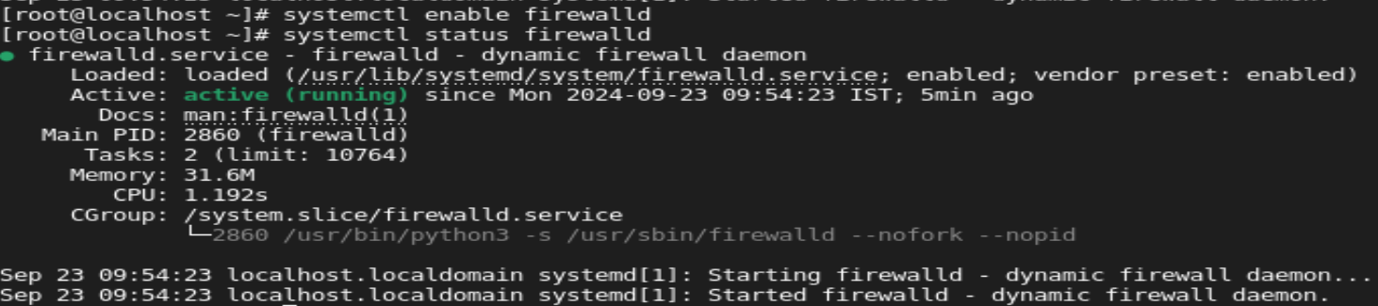

**DISABLE SERVICES**

**SYNTAX:**

* systemctl disable firewalld

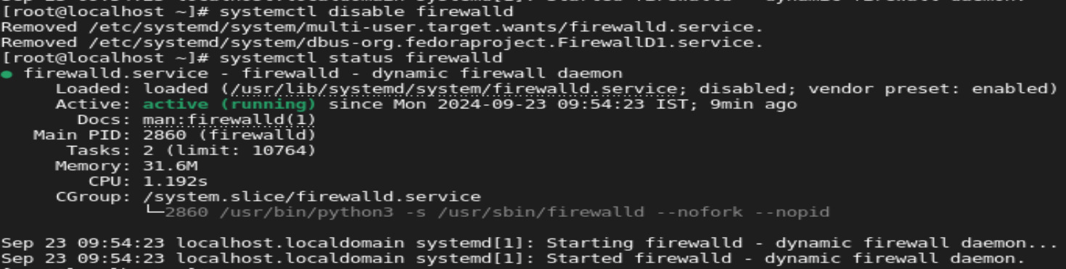

**ENABLE WITH START SERVICES**

**SYNTAX:**

* systemctl enable –now firewalld

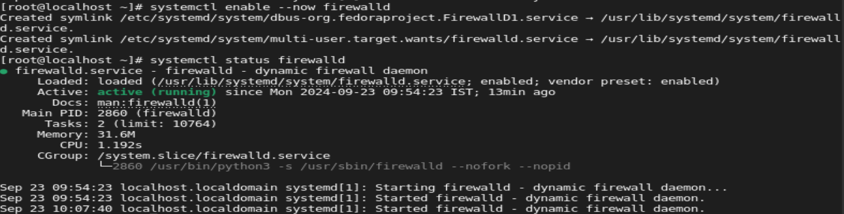

**DISABLE WITH STOP SERVICES**

**SYNTAX:**

* systemctl disable –now firewalld

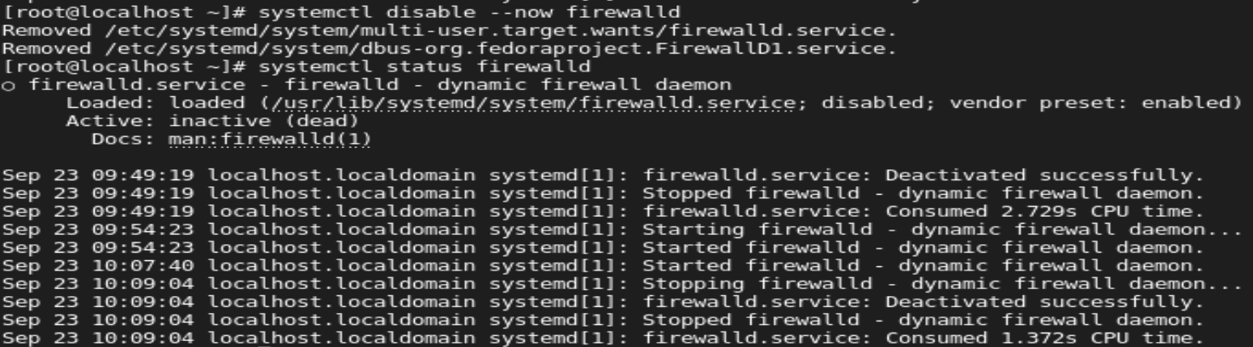

**TO CHECK WHETHER SERIVECES IS ACTIVE OR INACTIVE:**

**SYNTAX:**

* systemctl is-active firewalld

**ACTIVE STATE:**



**INACTIVE STATE:**



**LIST ALL SERVICES**

**SYNTAX:**

* **systemctl list-units –type service --all**

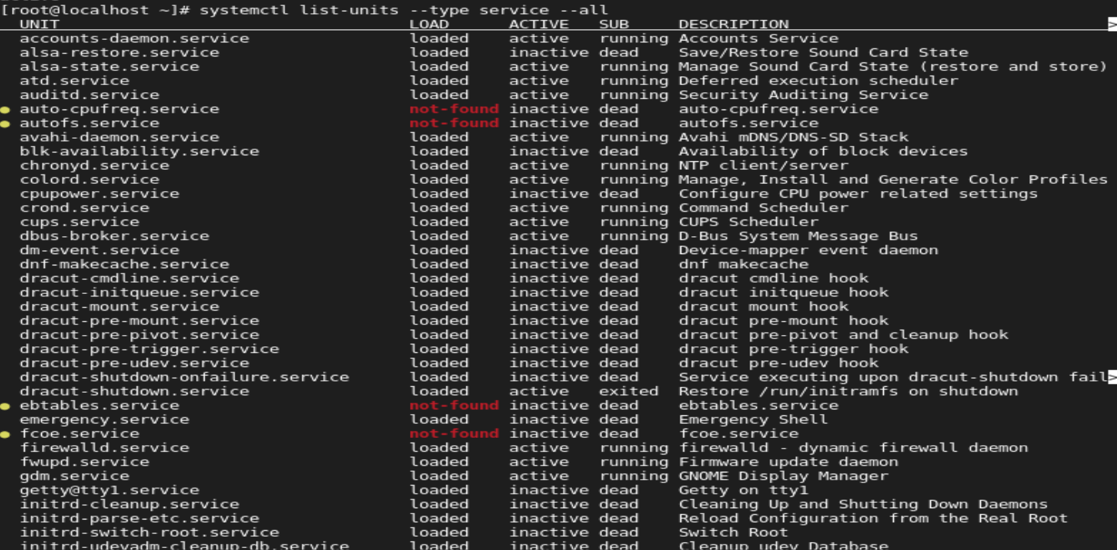

**LIST OF SERVICES THAT ARE ACTIVE NOW:**

**SYNTAX:**

* systemctl -t service

